Kenwood Zoom Setup Guide



### 

**Download App** **2**

Step 1 Go to Google Play or App Store 2

Step 2 Install App 2

**Join the Church Service** **3**

Step 1 App Loading Screen 3

Step 2 Join Meeting 3

Step 3 Meeting ID 4

Step 4 Add Name Info 4

Step 5 Join Options 5

Step 6 Connect Audio 5

**In Meeting Options** **6**

Muting 6

Unmute 6

### 

### Download App

#### Step 1 Go to Google Play or App Store

Go to the App store or Google Play store for android devices, the icon should look like the picture below



#### Step 2 Install App

Go to the App or Google Play Store and search for zoom, you should see the icon below. Install zoom on your device

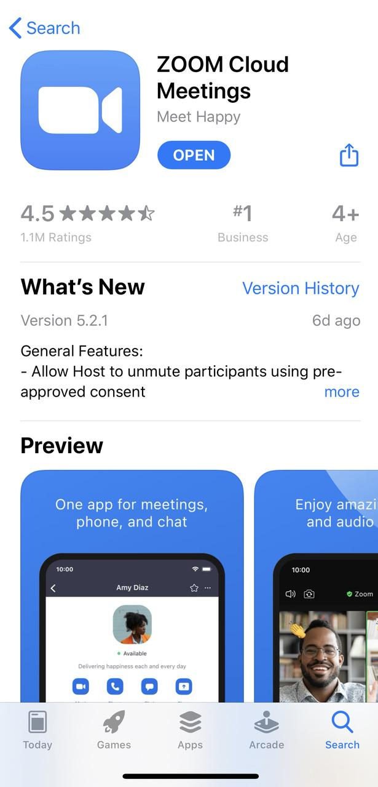

### **Join the Church Service**

#### Step 1 App Loading Screen

Open the Zoom app and click join a meeting. You don't need to sign up or sign in to participate.

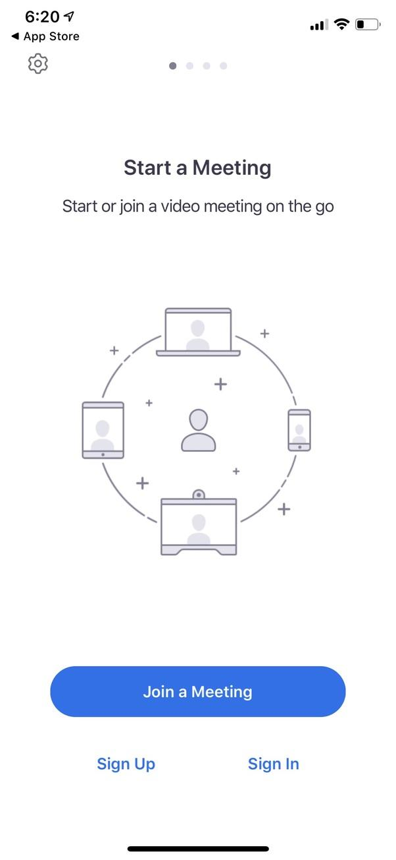

#### Step 2 Join Meeting

Once you click on join a meeting you will see the following to join the church service.

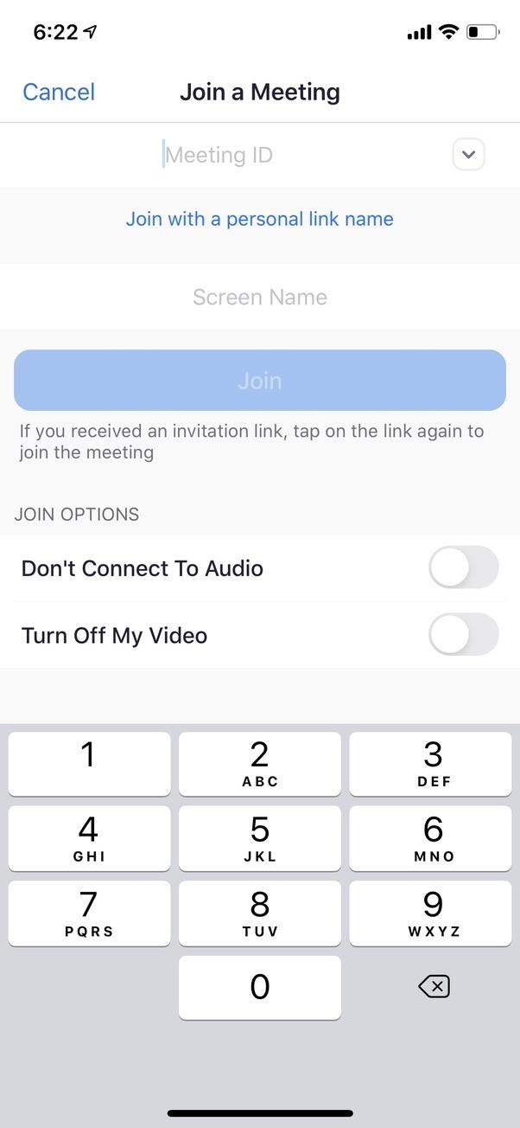

#### 

#### Step 3 Meeting ID

In the meeting ID space put in the meeting ID for our church, the meeting ID is 620 261 9489

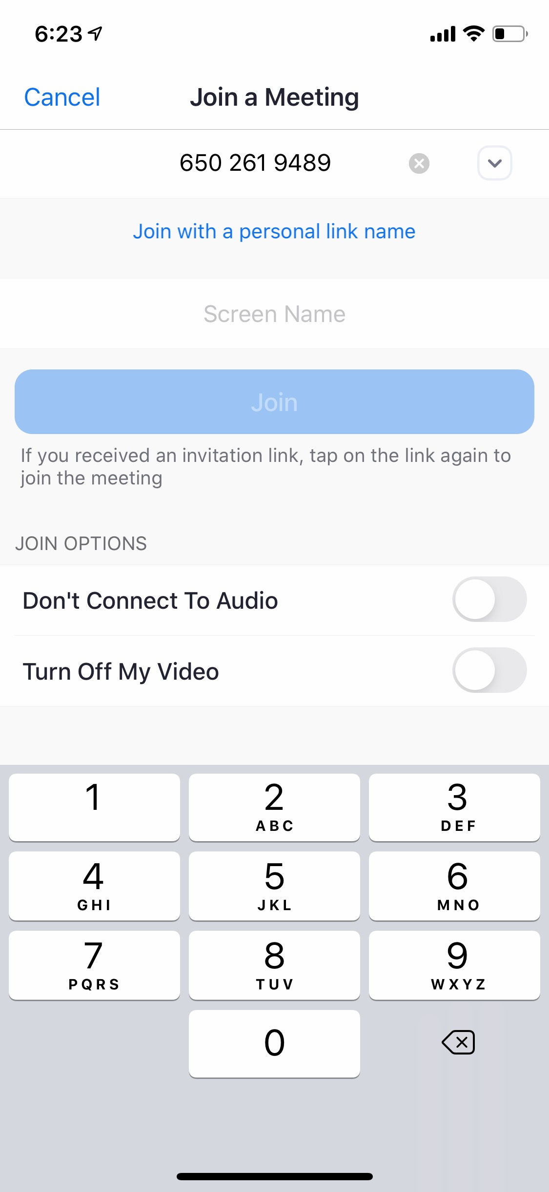

#### Step 4 Add Name Info

Put your name in below “Join with a personal link name”, see picture below

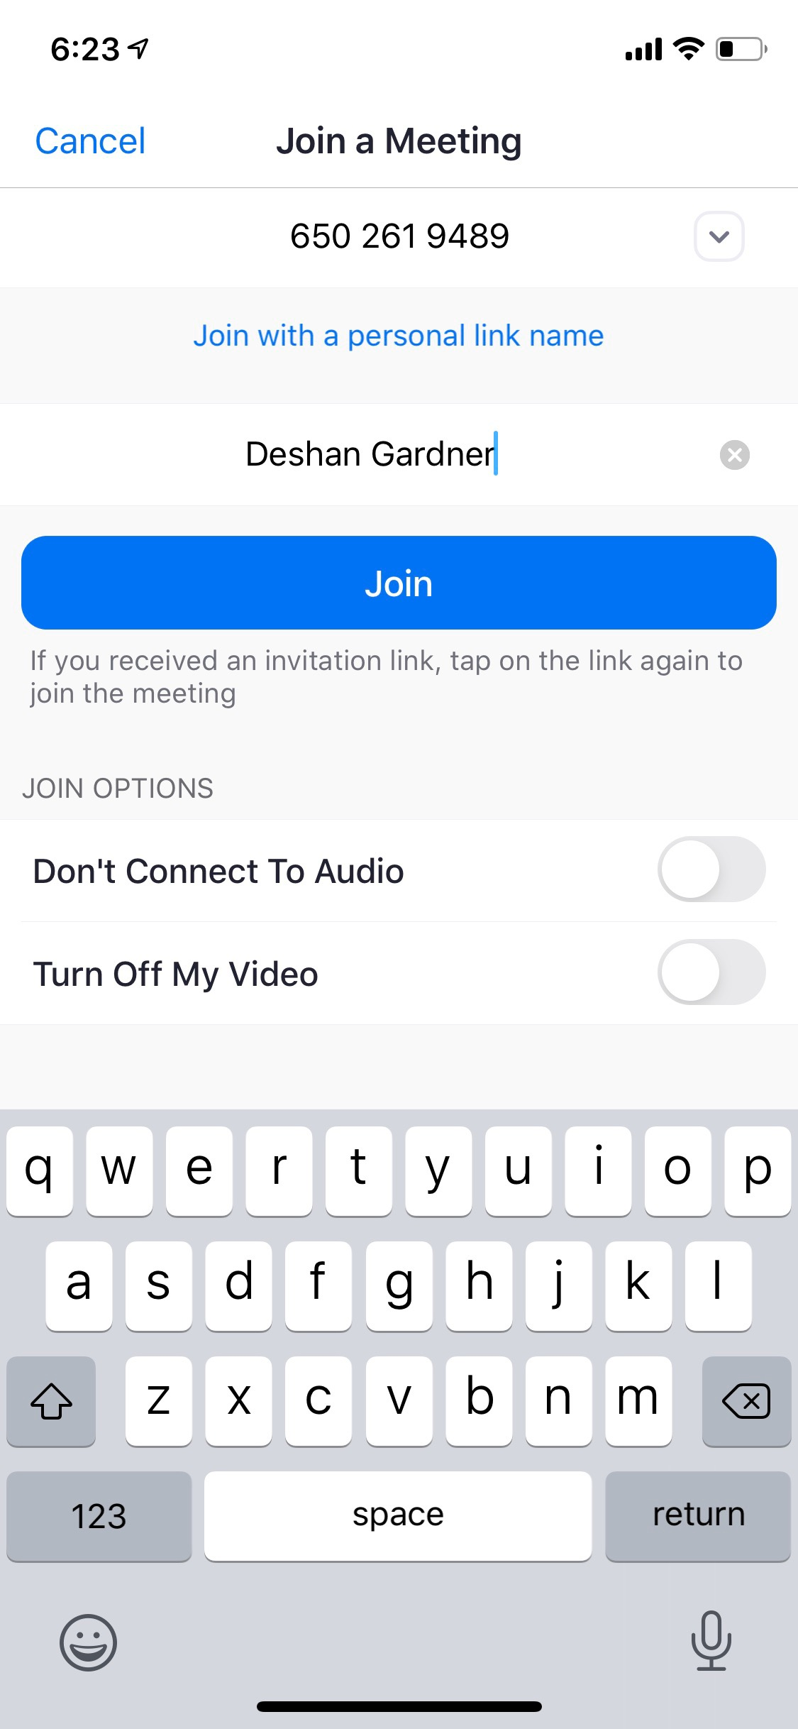

#### Step 5 Join Options

If you don't want to show video from your phone, check the option that says turn off my video. Click the join button to join the service.

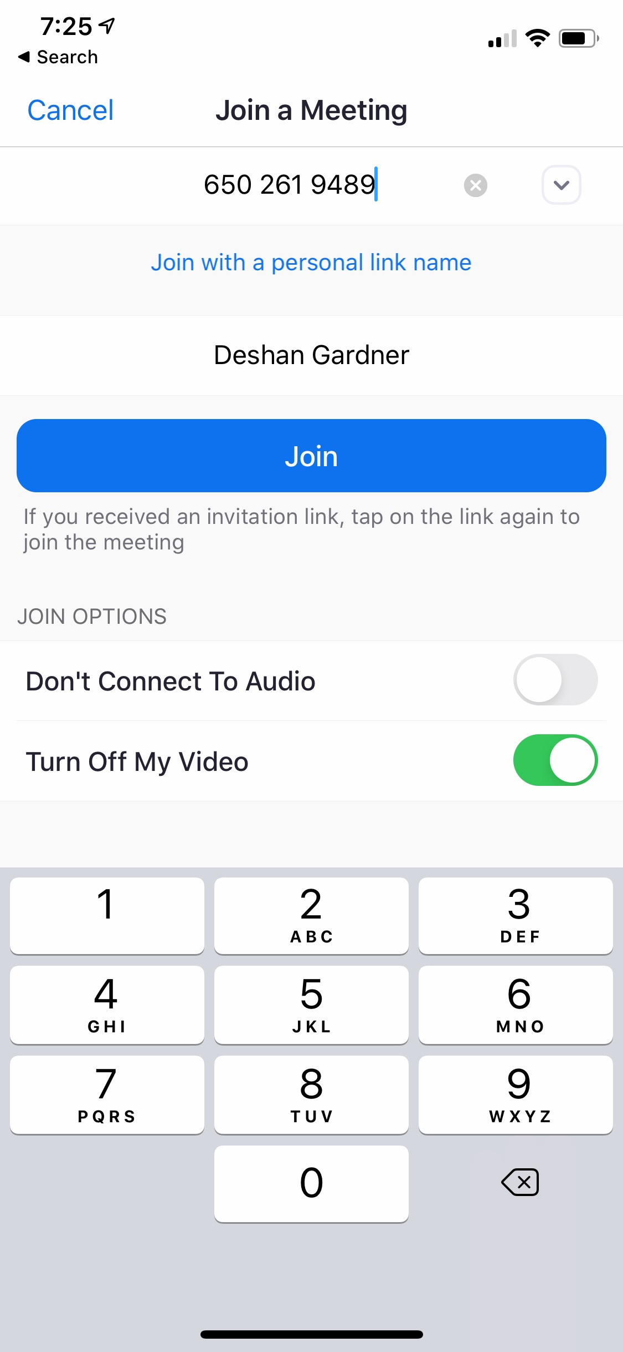

#### Step 6 Connect Audio

Once you click join you will see the screen below. Click call using internet audio to hear the meeting. After this you will be in the meeting.

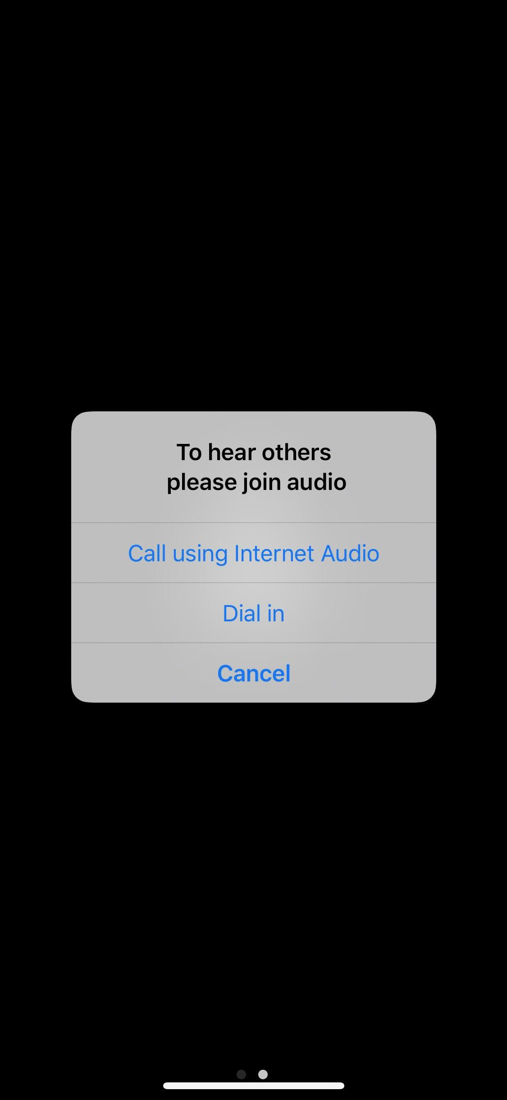

### In Meeting Options

#### Muting

Once you're in the meeting you will still need to mute yourself. If you are muted you will see a red line across the microphone icon.

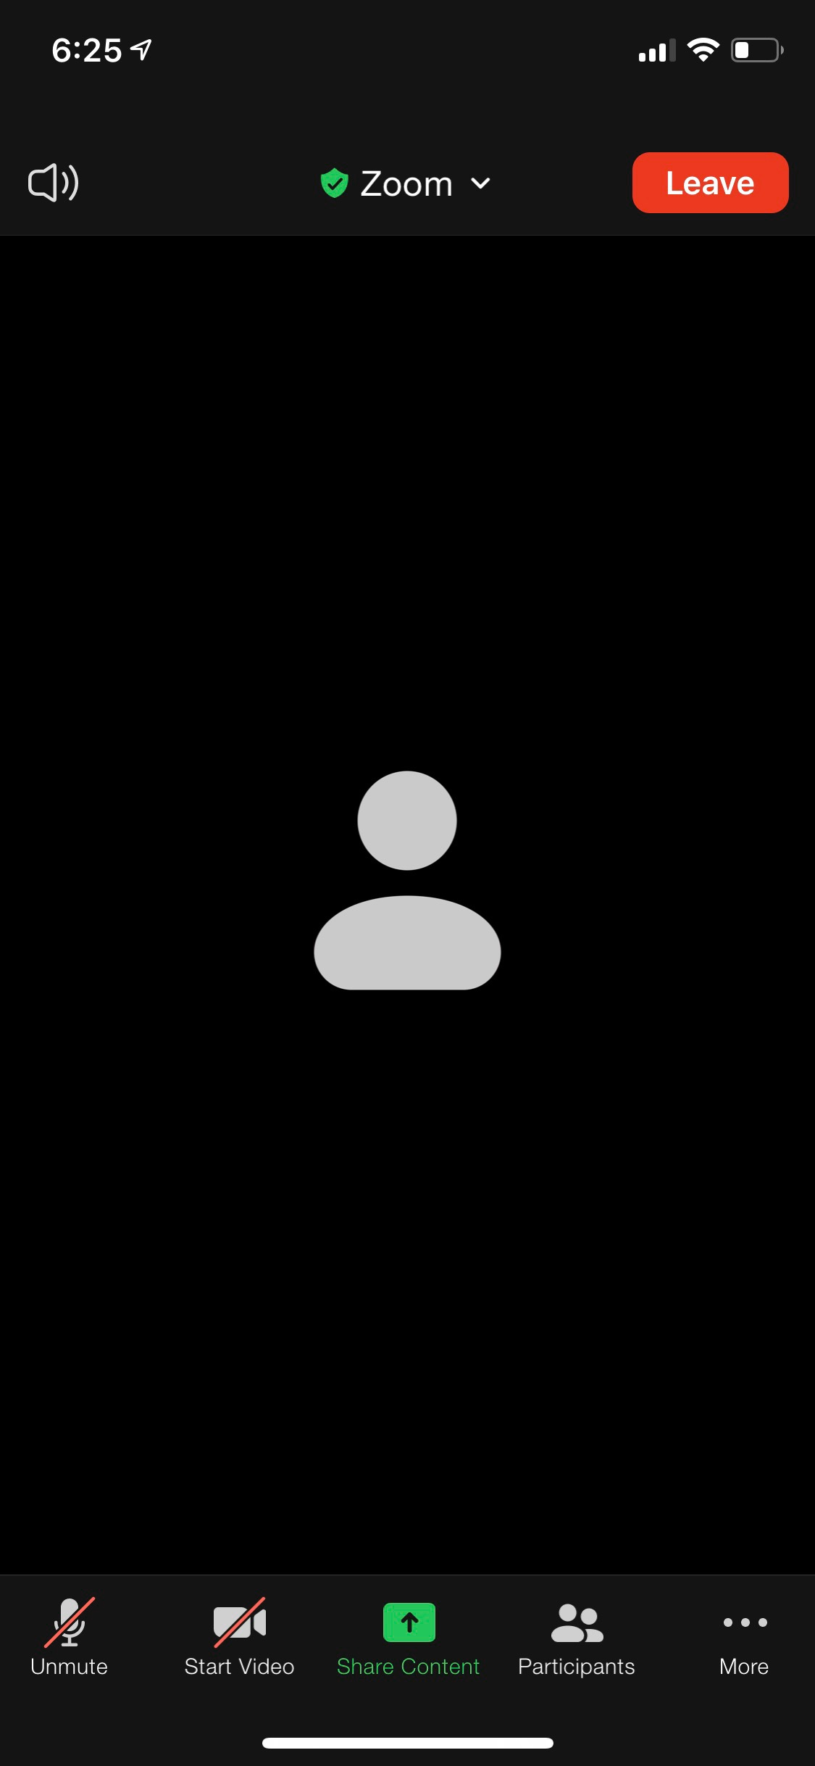

#### Unmute

To unmute you can click the unmute button on the bottom left of the screen. When you unmute the red vertical line will disappear. See below.

